ROOM xxx

Namexxx xxx

Job titlexxxxx

Email: xxx@ece.au.dk Tel: +-45 xx xx xx xx

ROOM XXX

Name Last Name

Job Title

Email: xxx@ece.au.dk Tel: +-45 xx xx xx xx

Name Last Name

Job Title

Email: xxx@ece.au.dk Tel: +-45 xx xx xx xx

ROOM 213

CHRISTINA KIRKEGAARD DOSE

Secretariat Staff Member

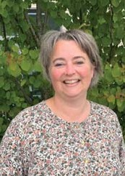
ckd@ece.au.dk
+45 4189 3016
- Journalising, WorkZone superuser
- NDA coordinator
- Access and keys
- Corona task force member

PERNILLE MØNSTER LETH

Secretariat Staff Member

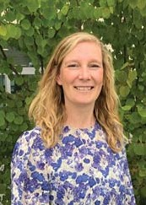
pml@ece.au.dk +45 9352 2682

•
- Recruitment and employments
- Holiday and absence
- Office trainee responsible
- Events

SARAH WISSENDORFF LEIFING

Office trainee

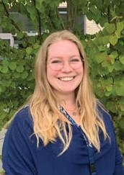
sale@ece.au.dk
+45 4189 3026
- Office supplies and other orders
- Contact person to Facility Management
- Danish - English translation
- Keys and access cards
- Distribution of mail and packages

